**Daraz Management System**



Session: 2021 – 2024

**Submitted by:**

Abdul Mateen 2021-CS-190

**Supervised by:**

Dr. Madam Maida

Department of Computer Science

**University of Engineering and Technology**

**Lahore Pakistan**

**Class Diagrams:**

1. **Domain Model With Classes Name:**

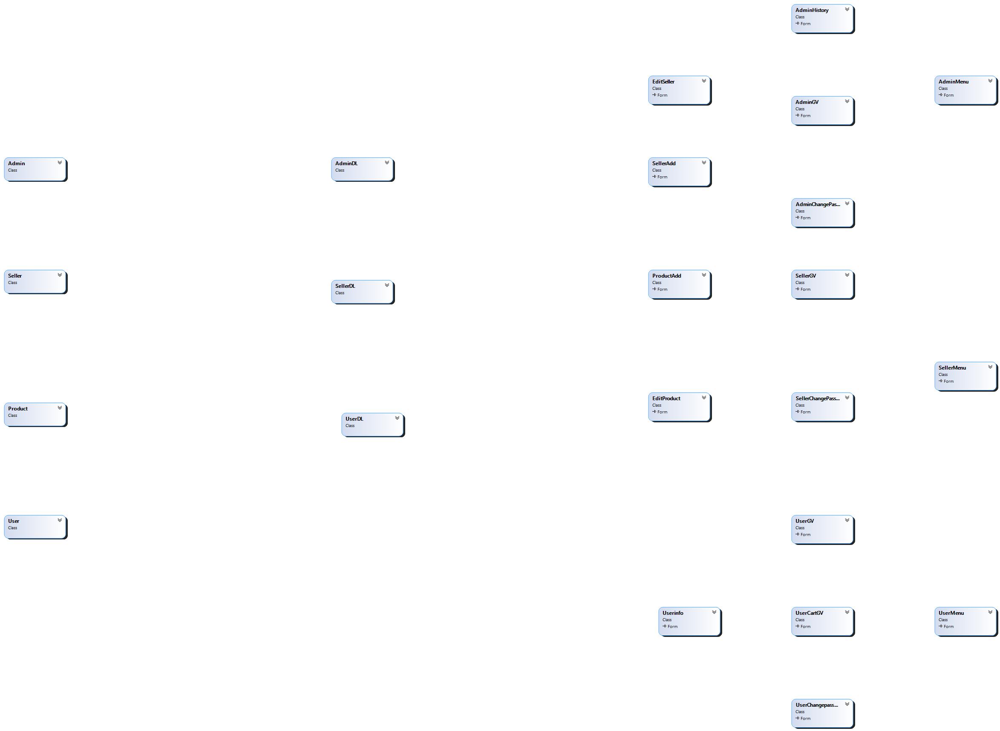

1. **Domain Model With Relation And Constraints:** 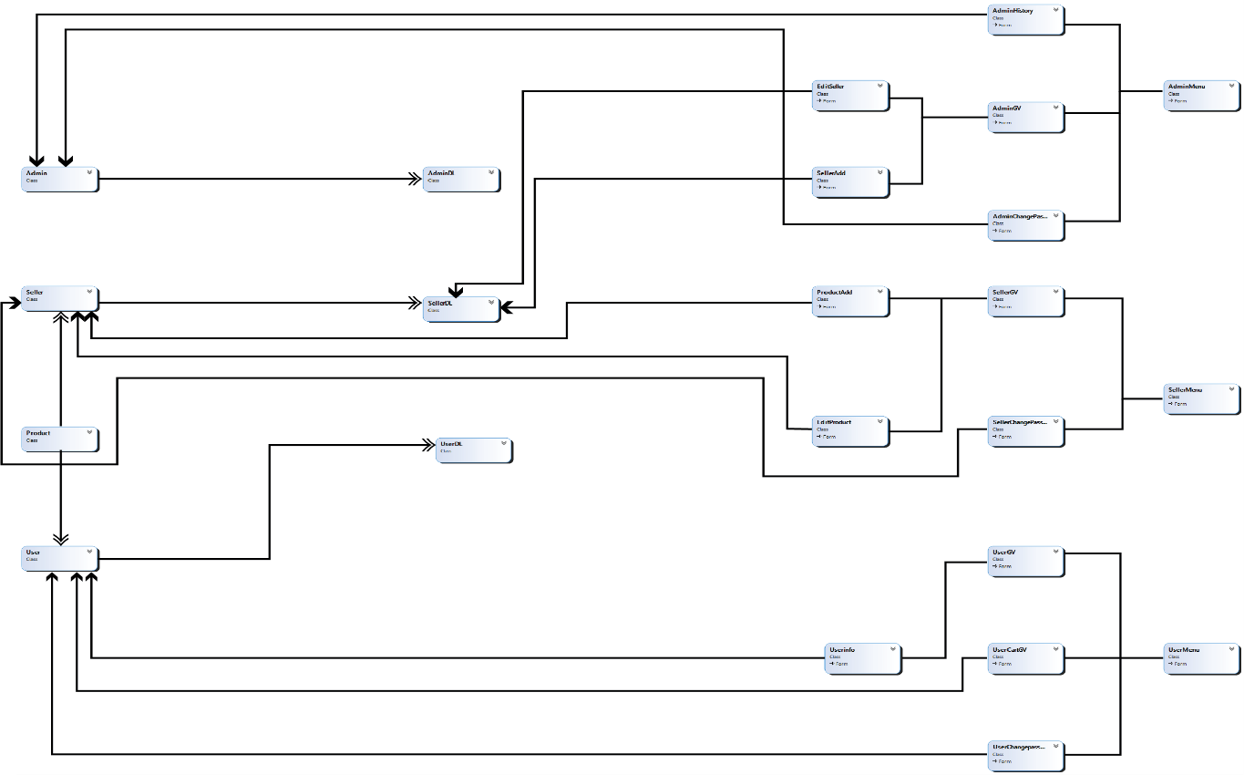

1. **Domain Model With Multiplicity:**

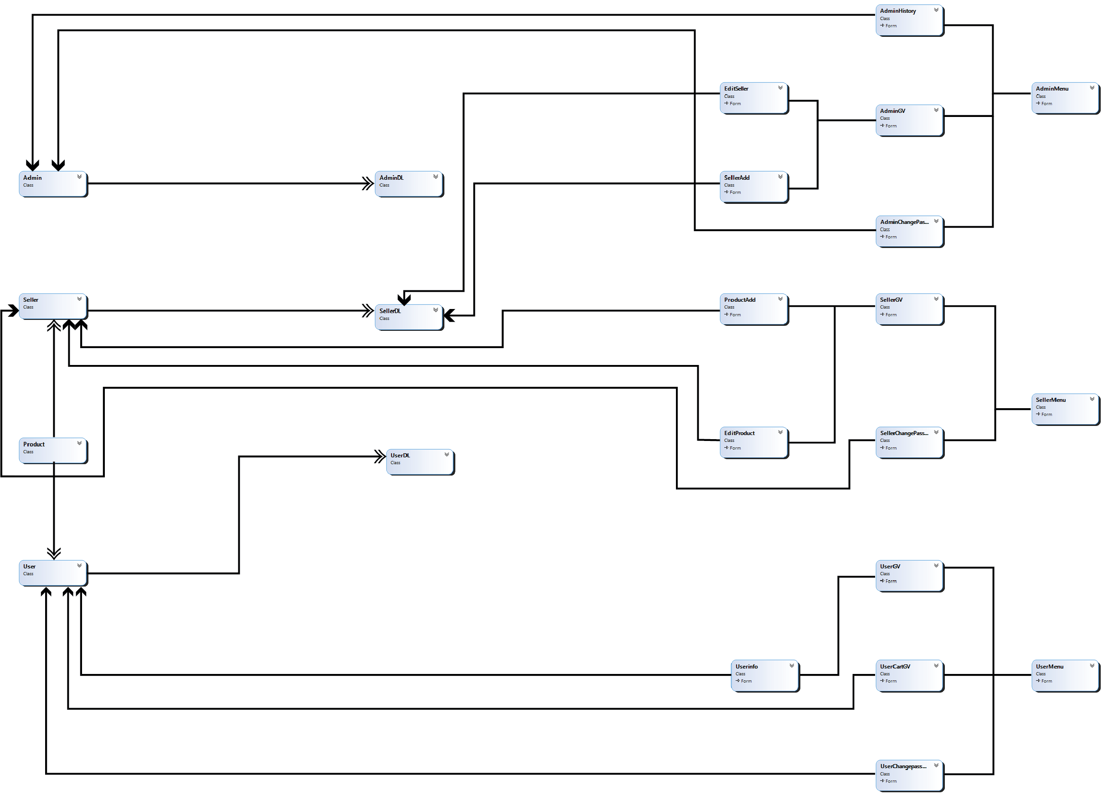

1. **Class Diagram:**

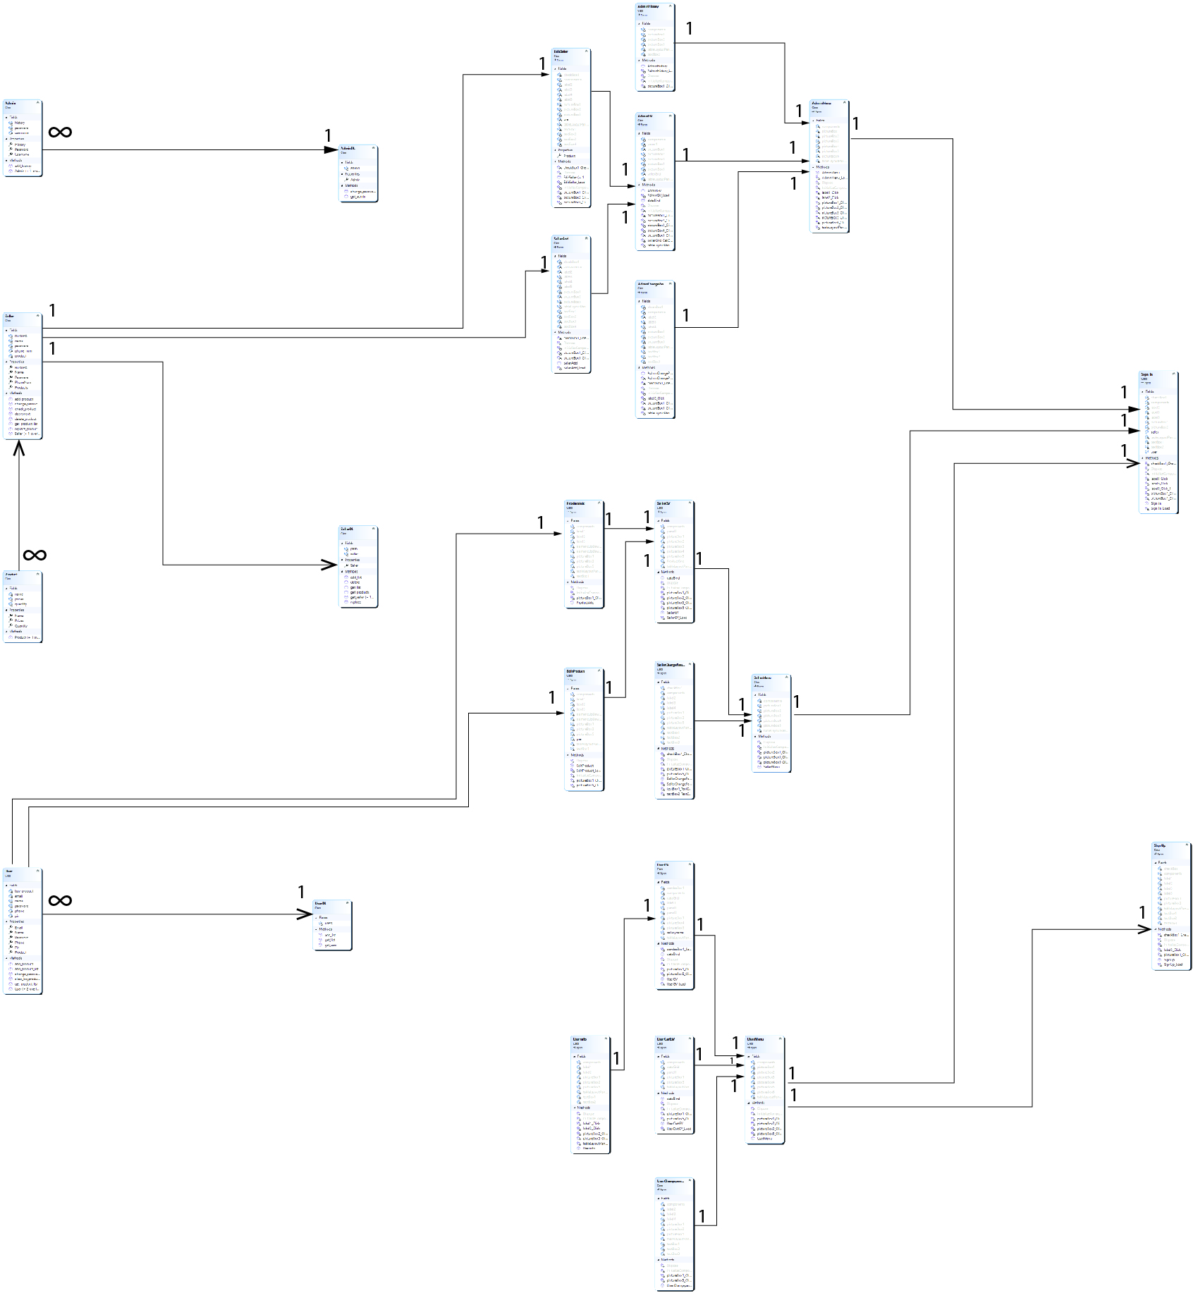

**WireFrames**

# 1. Login Forms

1. Sign In

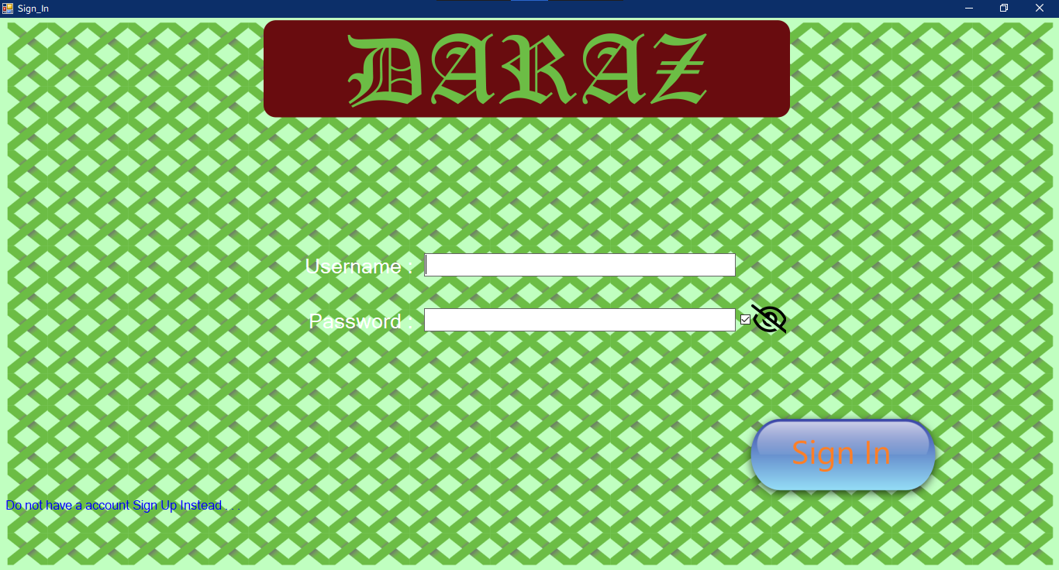

1. Sign Up

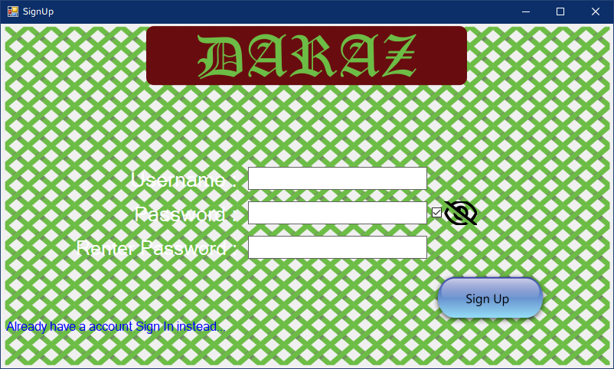

# 2.Admin Forms

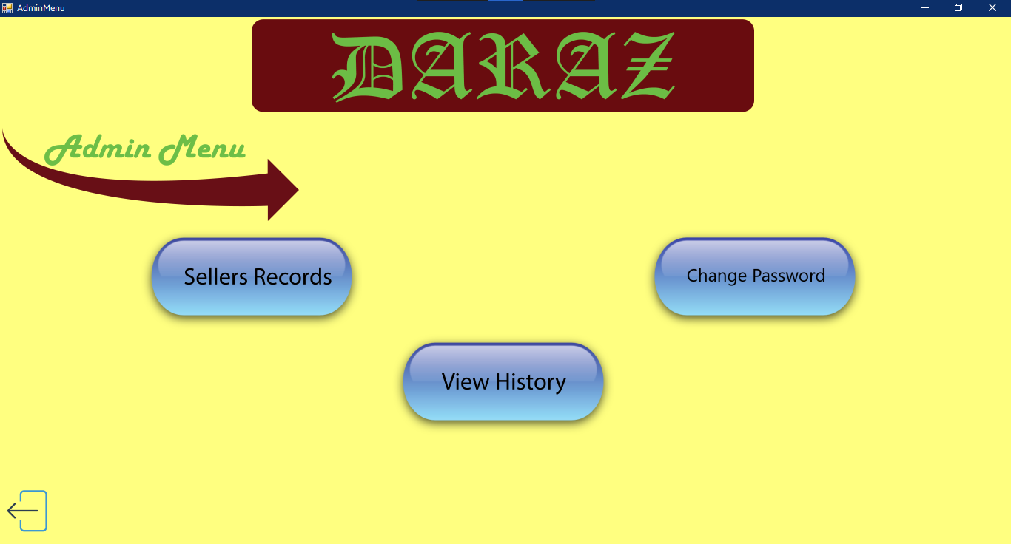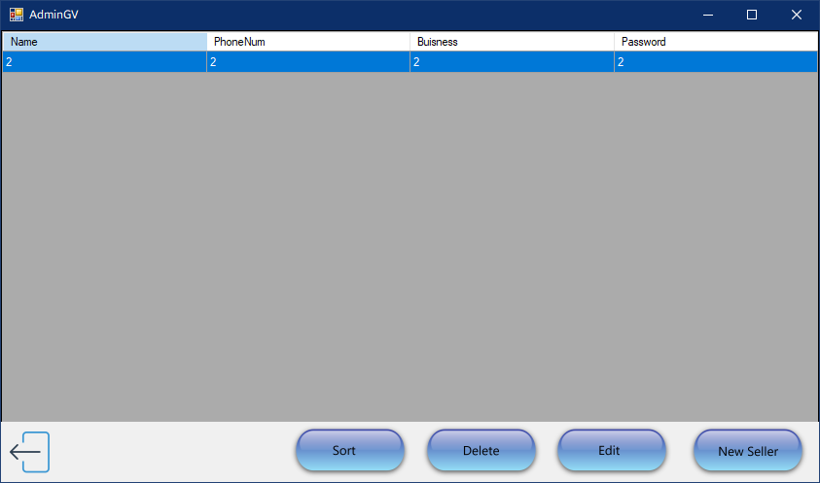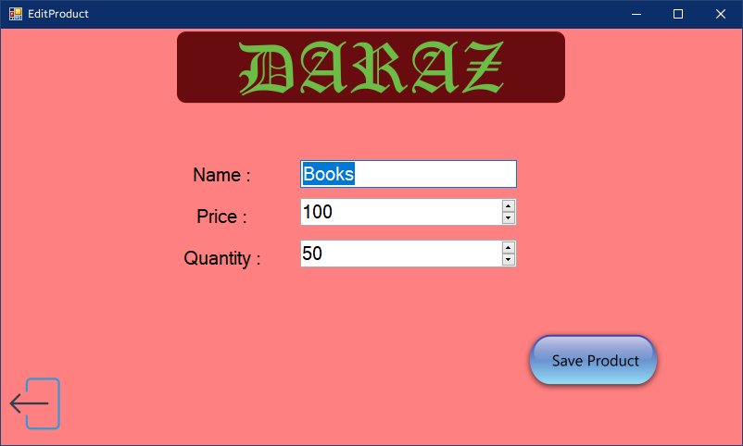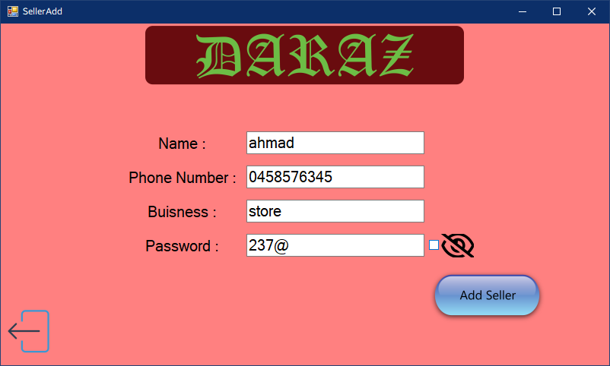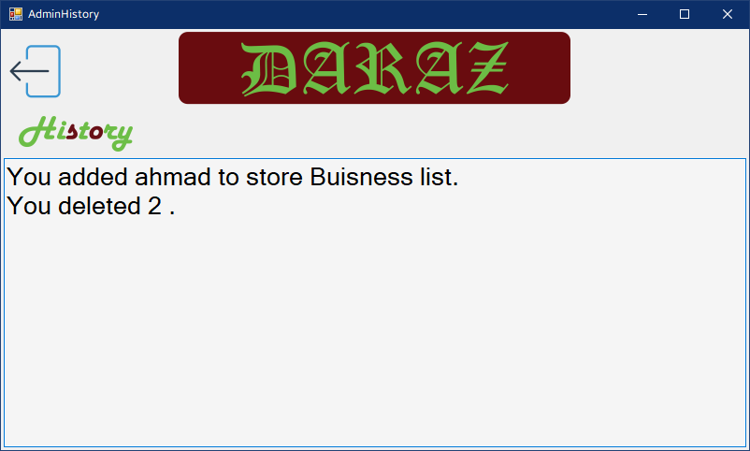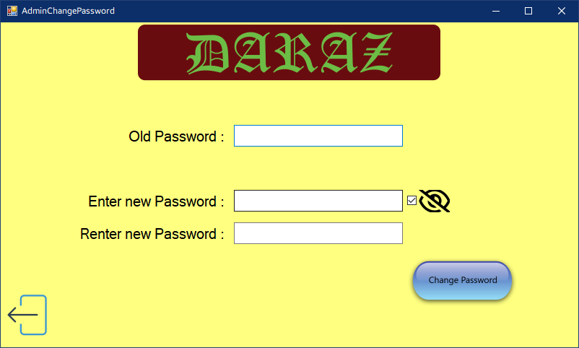

# 3.Seller Forms

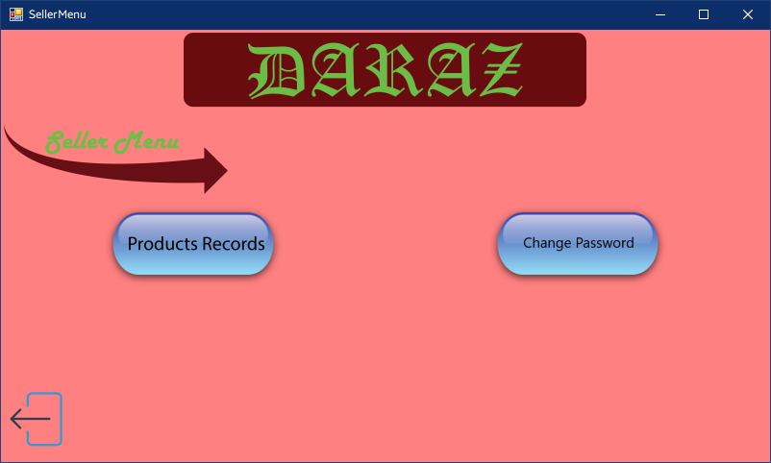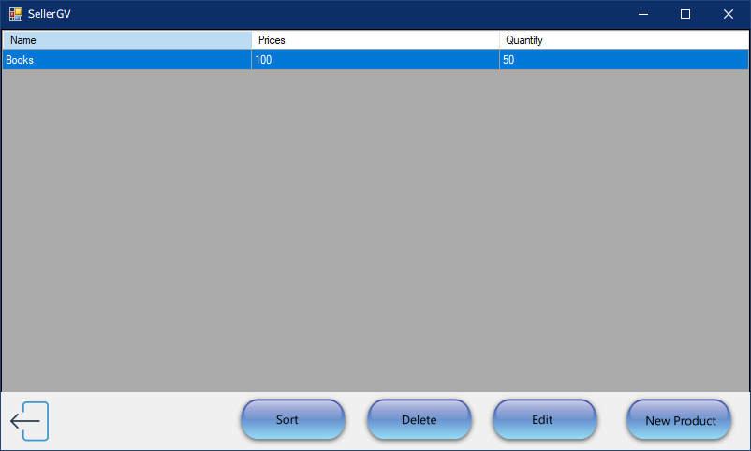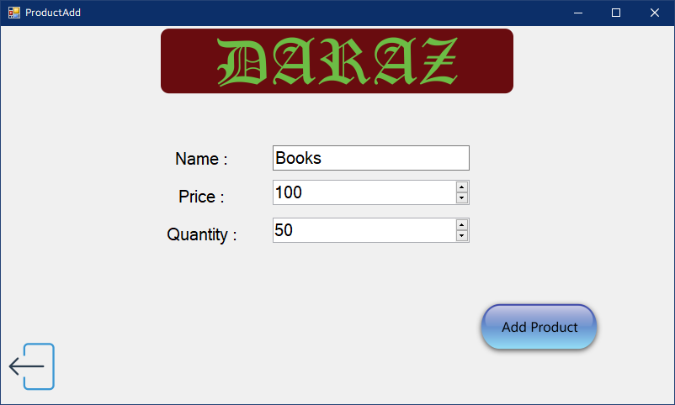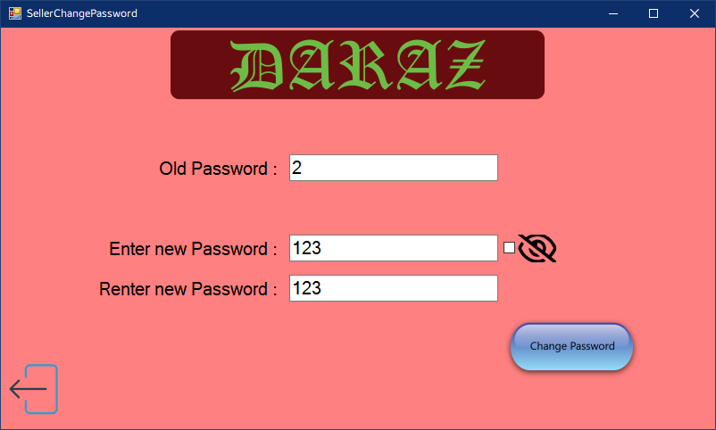

# 4.User Form

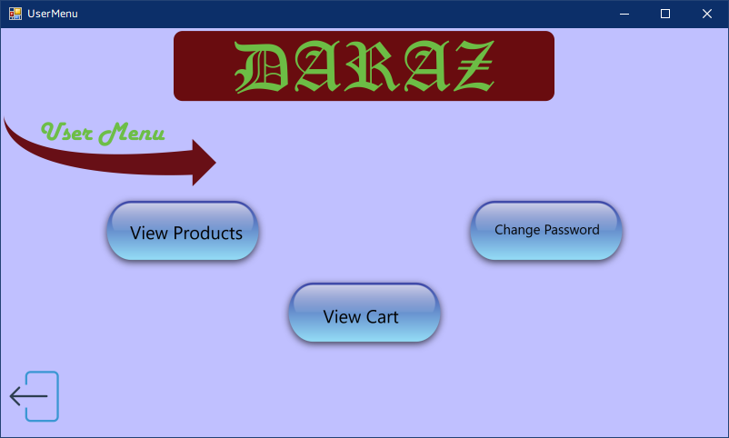

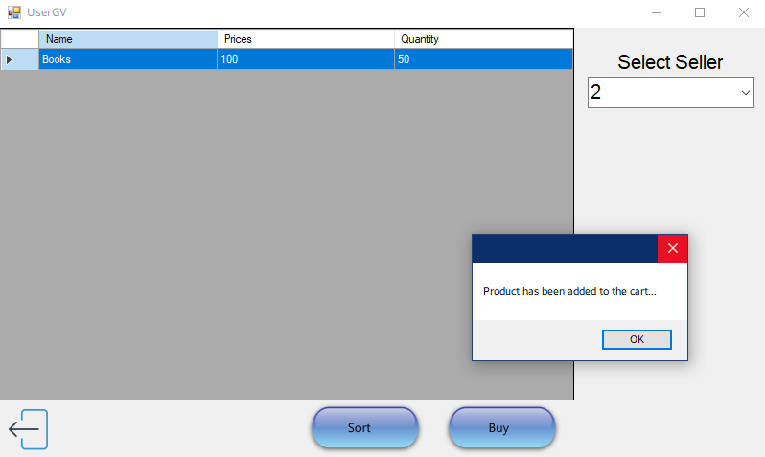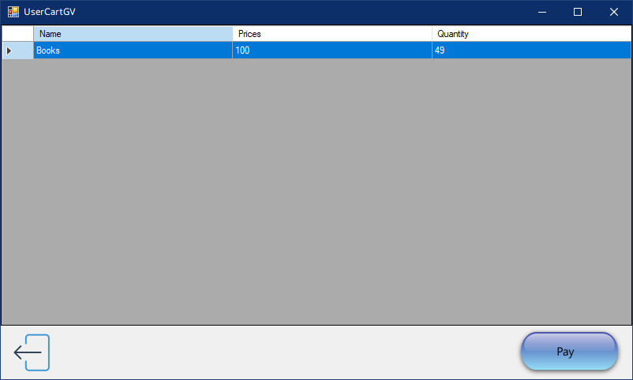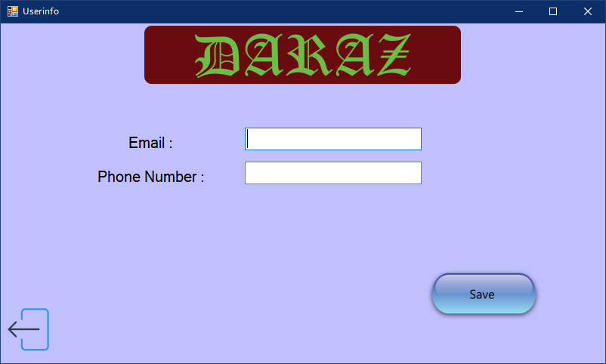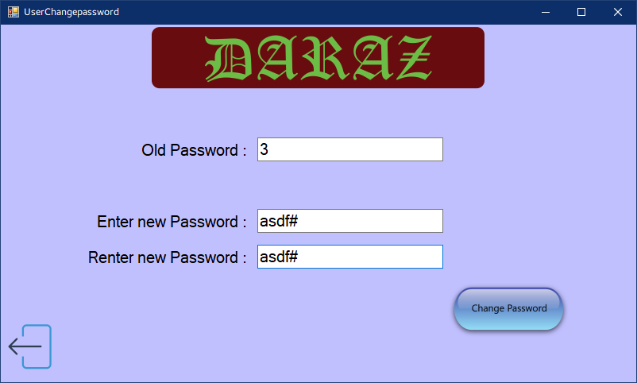

# Sequence Diagrams

# 1. Add

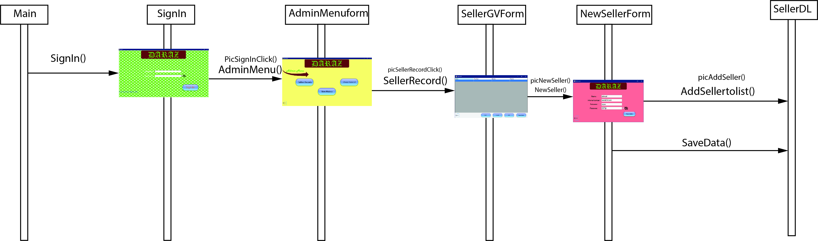

**2.Update**

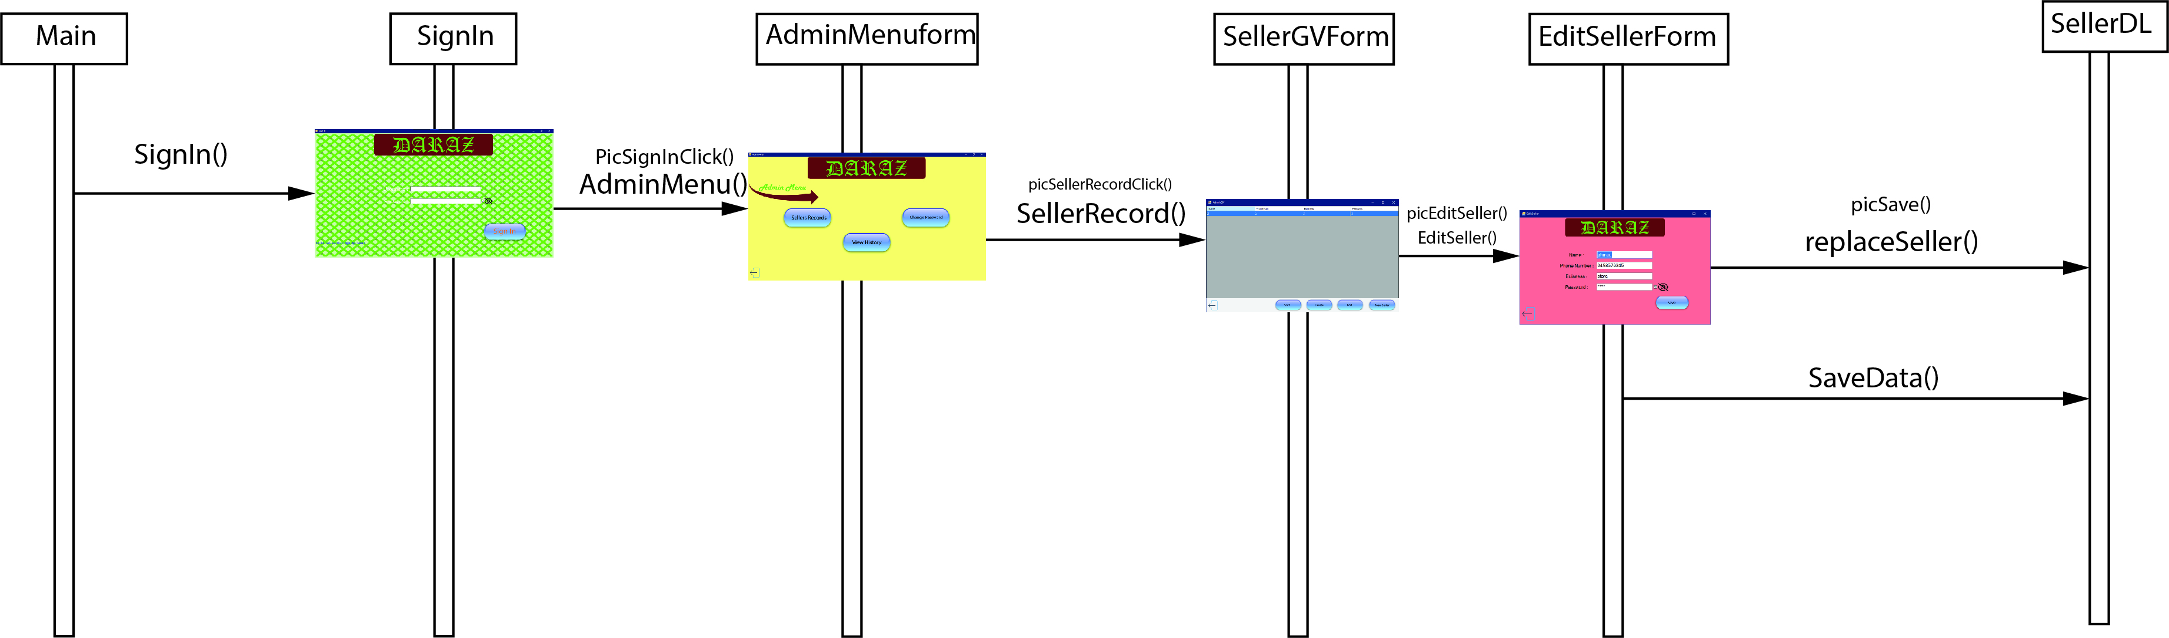

**3.Delete**

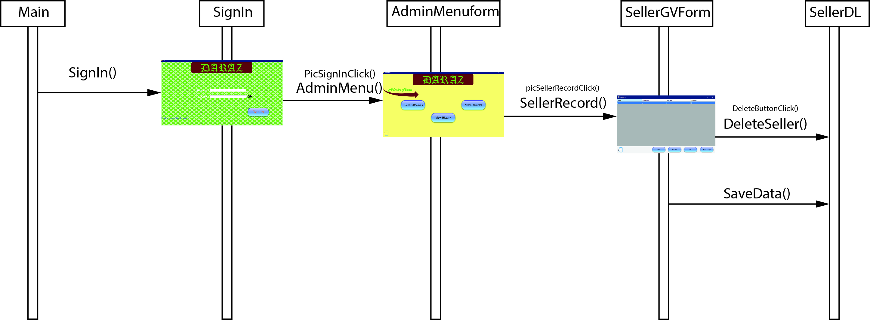

# 4 Change Password

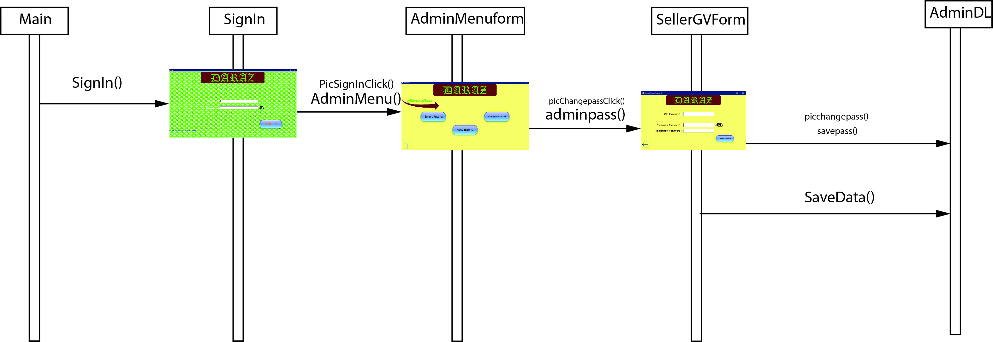

**Full Code**

**BL Classes**

**Admin class:**

class Admin

{

private string username="1";

private string password="1";

private List<string> history = new List<string>();

public List<string> History { get { return history; } }

public void add_history(string input)

{

history.Add(input);

}

public Admin() { }

public Admin(string username,string password)

{

this.password=password;

this.username=username;

}

public string Username{ get { return username; } set { username = value; } }

public string Password{ get { return password; } set { password = value; } }

}

**Seller Class:**

public class Seller

{

private string name;

private string phone_num;

private string buisness;

private string password;

private List<Product> product=new List<Product>();

public string Name{get { return name; } set { name = value; } }

public string PhoneNum{get { return phone_num; } set { phone_num = value; } }

public string Buisness{get { return buisness; } set { buisness = value; } }

public string Password{get { return password; } set { password = value; } }

public List<Product> Products { get { return product; } }

public Seller() { }

public Seller(string names,string ph,string buiss,string pass)

{

name=names;

phone_num=ph;

buisness=buiss;

password=pass;

}

public void add_product(Product input)

{

product.Add(input);

}

public List<Product> get_product_list()

{

return product;

}

public Product check_product(string name)

{

for (int i = 0; i < product.Count; i++)

{

if (name == product[i].Name)

{

return product[i];

}

}

return null;

}

public int change_password(string pass, string pass1, string pass2)

{

if (pass == this.Password)

{

if (pass1 == pass)

{

return 2;

}

else

{

if (pass1 == pass2)

{

this.Password = pass1;

return 3;

}

else

{

return 4;

}

}

}

else

{

return 1;

}

}

public void replace_product(Product pre,Product nw)

{

for (int i = 0; i < product.Count; i++)

{

if(product[i].Name==pre.Name && product[i].Prices==pre.Prices && product[i].Quantity==pre.Quantity)

{

product[i] = nw;

break;

}

}

}

public void delete_product(int index)

{

product.RemoveAt(index);

}

public bool decrement(Product a)

{

for (int i = 0; i < product.Count; i++)

{

if (product[i]==a)

{

if(a.Quantity>=1)

{

a.Quantity--;

return true;

}

}

}

return false;

}

}

**Product Class:**

public class Product

{

private string name;

private int prices;

private int quantity;

public string Name { get { return name; } set { name = value; } }

public int Prices { get { return prices; } set { prices = value; } }

public int Quantity { get { return quantity; } set { quantity = value; } }

public Product() { }

public Product(string name, int prices, int quantity)

{

Name = name;

Prices = prices;

Quantity = quantity;

}

}

**User Class:**

public class User

{

private string name;

private string password;

private string email="";

private string pin;

private string phone;

private List<Product> buy_product = new List<Product>();

public string Name { get { return name; } set { name = value; } }

public string Password { get { return password; } set { password = value; } }

public string Email { get { return email; } set { email = value; } }

public string Pin { get { return pin; } set { pin = value; } }

public string Phone { get { return phone; } set { phone = value; } }

public List<Product> Product { get { return buy_product; } }

public void add_product_list(Product input)

{

buy_product.Add(input);

}

public List<Product> get_product_list()

{

return buy_product;

}

public User() { }

public User(string name,string password)

{

this.name = name;

this.password = password;

}

public User(string names, string pass, string em,string pn,string ph)

{

name = names;

password = pass;

email=em;

pin=pn;

phone=ph;

}

public int change_password(string pass, string pass1, string pass2)

{

if (pass == this.Password)

{

if (pass1 == pass)

{

return 2;

}

else

{

if (pass1 == pass2)

{

this.Password = pass1;

return 3;

}

else

{

return 4;

}

}

}

else

{

return 1;

}

}

public void add_product(string name,int index)

{

for (int i = 0; i < SellerDL.Seller.Count; i++)

{

if (SellerDL.Seller[i].Name==name)

{

buy_product.Add(SellerDL.Seller[i].Products[index]);

break;

}

}

}

public void clear_buyproducts()

{

buy_product.Clear();

}

}

**DL Classes**

**Admin DL:**

class AdminDL

{

private static Admin admin = new Admin();

public static Admin Admin { get { return admin; } set { admin = value;} }

public static Admin get_admin(string name, string pass)

{

if (name == admin.Username && admin.Password == pass)

{

return admin;

}

else

{

return null;

}

}

public static int change_password(string pass,string pass1,string pass2)

{

if(pass==admin.Password)

{

if(pass1==pass)

{

return 2;

}

else

{

if(pass1==pass2)

{

admin.Password = pass1;

return 3;

}

else

{

return 4;

}

}

}

else

{

return 1;

}

}

}

**Seller DL:**

class SellerDL

{

static string path = "seller.txt";

private static List<Seller> seller = new List<Seller>();

public static List<Seller> Seller { get { return seller; } }

public static void add_list(Seller input)

{

seller.Add(input);

}

public static List<Seller> get_list()

{

return seller;

}

public static Seller get_seller(string seller_name,string pass)

{

for (int i = 0; i < seller.Count; i++)

{

if (seller_name == seller[i].Name && pass == seller[i].Password)

{

return seller[i];

}

}

return null;

}

public static Seller get_seller(string seller_name)

{

for (int i = 0; i < seller.Count; i++)

{

if (seller_name == seller[i].Name)

{

return seller[i];

}

}

return null;

}

public static void replace(Seller pre,Seller nw)

{

for (int i = 0; i < seller.Count; i++)

{

if (pre.Name == Seller[i].Name && pre.Buisness == Seller[i].Buisness && pre.PhoneNum == Seller[i].PhoneNum && pre.Password == Seller[i].Password)

{

Seller[i]= nw;

}

}

}

public static void delete(int index)

{

seller.RemoveAt(index);

}

public static List<Product> get_products(string name)

{

for (int i = 0; i < seller.Count; i++)

{

if (name == seller[i].Name)

{

return seller[i].Products;

}

}

return null;

}

}

**User DL:**

class UserDL

{

private static List<User> users= new List<User>();

public static void add_list(User input)

{

users.Add(input);

}

public static List<User> get_list()

{

return users;

}

public static User get_user(string name,string pass)

{

for (int i = 0; i < users.Count; i++)

{

if (name == users[i].Name && users[i].Password==pass)

{

return users[i];

}

}

return null;

}

}

Forms**:**

public partial class AdminChangePassword : Form

{

public AdminChangePassword()

{

InitializeComponent();

}

private void label2_Click(object sender, EventArgs e)

{

}

private void AdminChangePassword_Load(object sender, EventArgs e)

{

if (pass_chk.Checked)

{

txtboxnewpass1.PasswordChar = '*';

txtboxnewpass2.PasswordChar = '*';

}

else if (!pass_chk.Checked)

{

txtboxnewpass1.PasswordChar = '\0';

txtboxnewpass2.PasswordChar = '\0';

}

}

private void pictureBox1_Click(object sender, EventArgs e)

{

int chk = AdminDL.change_password(txtboxoldpass.Text, txtboxnewpass1.Text, txtboxnewpass2.Text);

if (chk == 1)

{

MessageBox.Show("Wrong Password.");

txtboxoldpass.Clear();

}

else if (chk == 2)

{

MessageBox.Show("New Password can not be the Old Password.");

}

else if (chk == 3)

{

AdminDL.store_data();

AdminDL.Admin.add_history("You changed password .");

MessageBox.Show("Password has been changed.");

this.Hide();

AdminMenu a = new AdminMenu();

a.Show();

}

else if (chk == 4)

{

MessageBox.Show("New Passwords does not match.");

}

txtboxnewpass1.Clear();

txtboxnewpass2.Clear();

txtboxoldpass.Focus();

}

private void tableLayoutPanel1_Paint(object sender, PaintEventArgs e)

{

}

private void pictureBox5_Click(object sender, EventArgs e)

{

this.Hide();

AdminMenu m = new AdminMenu();

m.Show();

}

private void checkBox1_CheckedChanged(object sender, EventArgs e)

{

if (pass_chk.Checked)

{

txtboxnewpass1.PasswordChar = '*';

txtboxnewpass2.PasswordChar = '*';

}

else if (!pass_chk.Checked)

{

txtboxnewpass1.PasswordChar = '\0';

txtboxnewpass2.PasswordChar = '\0';

}

}

}

public partial class AdminGV : Form

{

public AdminGV()

{

InitializeComponent();

}

private void AdminGV_Load(object sender, EventArgs e)

{

dataBind();

}

public void dataBind()

{

sellerGrid.DataSource = null;

sellerGrid.DataSource = SellerDL.get_list();

sellerGrid.Refresh();

}

private void pictureBox2_Click_1(object sender, EventArgs e)

{

if(SellerDL.Seller.Count>0)

{

int rowindex = sellerGrid.CurrentCell.RowIndex;

EditSeller form = new EditSeller(SellerDL.Seller[rowindex]);

this.Hide();

form.Show();

//store all data

dataBind();

}

}

private void pictureBox1_Click_1(object sender, EventArgs e)

{

SellerAdd a = new SellerAdd();

a.ShowDialog();

AdminGV adminGV=new AdminGV();

this.Hide();

adminGV.Show();

}

private void pictureBox3_Click(object sender, EventArgs e)

{

if(SellerDL.Seller.Count>0)

{

int rowindex = sellerGrid.CurrentCell.RowIndex;

AdminDL.Admin.add_history("You deleted " + SellerDL.Seller[rowindex].Name+" .");

SellerDL.delete(rowindex);

//store all data

//save file

dataBind();

SellerDL.store_data();

UserDL.store_data();

}

}

private void pictureBox4_Click(object sender, EventArgs e)

{

}

private void pictureBox5_Click(object sender, EventArgs e)

{

this.Hide();

AdminMenu a = new AdminMenu();

a.Show();

}

private void sellerGrid_CellContentClick(object sender, DataGridViewCellEventArgs e)

{

}

private void tableLayoutPanel1_Paint(object sender, PaintEventArgs e)

{

}

}

public partial class AdminHistory : Form

{

public AdminHistory()

{

InitializeComponent();

}

private void AdminHistory_Load(object sender, EventArgs e)

{

for (int i = 0; i < AdminDL.Admin.History.Count; i++)

{

txtboxhistory.AppendText(AdminDL.Admin.History[i]+Environment.NewLine);

}

}

private void pictureBox5_Click(object sender, EventArgs e)

{

this.Hide();

AdminMenu a = new AdminMenu();

a.Show();

}

}

public partial class AdminMenu : Form

{

public AdminMenu()

{

InitializeComponent();

}

private void AdminMenu_Load(object sender, EventArgs e)

{

}

private void pictureBox1_Click(object sender, EventArgs e)

{

this.Hide();

AdminChangePassword a = new AdminChangePassword();

a.Show();

}

private void pictureBox2_Click(object sender, EventArgs e)

{

AdminGV a = new AdminGV();

a.Show();

this.Hide();

}

private void pictureBox3_Click(object sender, EventArgs e)

{

this.Hide();

AdminHistory h = new AdminHistory();

h.Show();

}

private void label1_Click(object sender, EventArgs e)

{

}

private void label2_Click(object sender, EventArgs e)

{

}

private void tableLayoutPanel1_Paint(object sender, PaintEventArgs e)

{

}

private void pictureBox5_Click(object sender, EventArgs e)

{

this.Hide();

Sign_In a = new Sign_In();

a.Show();

}

private void pictureBox6_Click(object sender, EventArgs e)

{

}

}

public partial class EditProduct : Form

{

Product pre = new Product();

public EditProduct(Product p)

{

InitializeComponent();

pre = p;

}

private void EditProduct_Load(object sender, EventArgs e)

{

txtboxname.Text= pre.Name;

numprice.Value = pre.Prices;

numquantity.Value = pre.Quantity;

txtboxname.Focus();

}

private void pictureBox1_Click(object sender, EventArgs e)

{

Product nw = new Product(txtboxname.Text, (int)numprice.Value, (int)numquantity.Value);

Sign_In.seller.replace_product(pre, nw);

//save all to file

//save

SellerDL.store_data();

UserDL.store_data();

this.Hide();

SellerGV d = new SellerGV();

d.Show();

}

private void pictureBox5_Click(object sender, EventArgs e)

{

this.Hide();

SellerGV d = new SellerGV();

d.Show();

}

}

public partial class EditSeller : Form

{

Seller pre = new Seller();

public Product Product { get; }

public EditSeller(Seller s)

{

InitializeComponent();

pre = s;

}

public EditSeller(Product product)

{

Product = product;

}

private void pictureBox1_Click(object sender, EventArgs e)

{

Seller nw = new Seller(txtboxname.Text, txtboxpass.Text, txtboxbuisness.Text, txtboxphone.Text);

SellerDL.replace(pre, nw);

AdminDL.Admin.add_history("You edited " + txtboxname.Text + " .");

//save all to file

//save

SellerDL.store_data();

UserDL.store_data();

this.Hide();

AdminGV a = new AdminGV();

a.Show();

}

private void EditSeller_Load(object sender, EventArgs e)

{

if (pass_chk.Checked)

{

txtboxpass.PasswordChar = '*';

}

else if (!pass_chk.Checked)

{

txtboxpass.PasswordChar = '\0';

}

txtboxname.Text = pre.Name;

txtboxpass.Text = pre.PhoneNum;

txtboxbuisness.Text = pre.Buisness;

txtboxphone.Text = pre.Password;

txtboxname.Focus();

}

private void pictureBox2_Click(object sender, EventArgs e)

{

}

private void pictureBox5_Click(object sender, EventArgs e)

{

this.Hide();

AdminGV a = new AdminGV();

a.Show();

}

private void checkBox1_CheckedChanged(object sender, EventArgs e)

{

if (pass_chk.Checked)

{

txtboxpass.PasswordChar = '*';

}

else if (!pass_chk.Checked)

{

txtboxpass.PasswordChar = '\0';

}

}

}

public partial class Main_Menu : Form

{

public Main_Menu()

{

InitializeComponent();

}

private void Main_Menu_Load(object sender, EventArgs e)

{

}

private void button1_Click_2(object sender, EventArgs e)

{

Sign_In open = new Sign_In();

this.Hide();

open.Show();

}

private void pictureBox_MouseDown(object sender, MouseEventArgs e)

{

}

private void Main_Menu_Paint(object sender, PaintEventArgs e)

{

}

private void Main_Menu_MouseMove(object sender, MouseEventArgs e)

{

}

private void Main_Menu_MouseUp(object sender, MouseEventArgs e)

{

}

private void Main_Menu_MouseDown(object sender, MouseEventArgs e)

{

}

private void pictureBox_MouseUp(object sender, MouseEventArgs e)

{

}

}

public partial class Main_Menu : Form

{

public Main_Menu()

{

InitializeComponent();

}

private void Main_Menu_Load(object sender, EventArgs e)

{

}

private void button1_Click_2(object sender, EventArgs e)

{

Sign_In open = new Sign_In();

this.Hide();

open.Show();

}

private void pictureBox_MouseDown(object sender, MouseEventArgs e)

{

}

private void Main_Menu_Paint(object sender, PaintEventArgs e)

{

}

private void Main_Menu_MouseMove(object sender, MouseEventArgs e)

{

}

private void Main_Menu_MouseUp(object sender, MouseEventArgs e)

{

}

private void Main_Menu_MouseDown(object sender, MouseEventArgs e)

{

}

private void pictureBox_MouseUp(object sender, MouseEventArgs e)

{

}

}

public partial class ProductAdd : Form

{

public ProductAdd()

{

InitializeComponent();

}

private void pictureBox1_Click(object sender, EventArgs e)

{

int a = (int)numprice.Value;

Product p = new Product(txtboxname.Text, (int)numprice.Value , (int)numquantity.Value );

Sign_In.seller.add_product(p);

SellerDL.store_data();

this.Hide();

}

private void ProductAdd_Load(object sender, EventArgs e)

{

}

}

public partial class SellerAdd : Form

{

public SellerAdd()

{

InitializeComponent();

}

private void SellerAdd_Load(object sender, EventArgs e)

{

if (pass_chk.Checked)

{

txtboxpass.PasswordChar = '*';

}

else if (!pass_chk.Checked)

{

txtboxpass.PasswordChar = '\0';

}

}

private void pictureBox1_Click(object sender, EventArgs e)

{

Seller s = new Seller(txtboxname.Text, txtboxpass.Text, txtboxbuisness.Text, txtboxphonenum.Text);

SellerDL.add_list(s);

AdminDL.Admin.add_history("You added "+txtboxname.Text+" to "+txtboxbuisness.Text+" Buisness list.");

SellerDL.store_data();

//store to file

//save file

this.Hide();

}

private void pictureBox5_Click(object sender, EventArgs e)

{

this.Hide();

}

private void checkBox1_CheckedChanged(object sender, EventArgs e)

{

if (pass_chk.Checked)

{

txtboxpass.PasswordChar = '*';

}

else if (!pass_chk.Checked)

{

txtboxpass.PasswordChar = '\0';

}

}

}

public partial class SellerChangePassword : Form

{

public SellerChangePassword()

{

InitializeComponent();

}

private void textBox1_TextChanged(object sender, EventArgs e)

{

}

private void textBox2_TextChanged(object sender, EventArgs e)

{

}

private void pictureBox1_Click(object sender, EventArgs e)

{

int chk = Sign_In.seller.change_password(txtboxoldpass.Text, txtboxnewpass1.Text, txtboxnewpass2.Text);

if (chk == 1)

{

MessageBox.Show("Wrong Password.");

txtboxoldpass.Clear();

}

else if (chk == 2)

{

MessageBox.Show("New Password can not be the Old Password.");

}

else if (chk == 3)

{

MessageBox.Show("Password has been changed.");

SellerDL.store_data();

this.Hide();

SellerMenu n = new SellerMenu();

n.Show();

}

else if (chk == 4)

{

MessageBox.Show("New Passwords does not match.");

}

txtboxnewpass1.Clear();

txtboxnewpass2.Clear();

txtboxoldpass.Focus();

}

private void SellerChangePassword_Load(object sender, EventArgs e)

{

if (checkBox1.Checked)

{

txtboxnewpass1.PasswordChar = '*';

txtboxnewpass2.PasswordChar = '*';

}

else if (!checkBox1.Checked)

{

txtboxnewpass1.PasswordChar = '\0';

txtboxnewpass2.PasswordChar = '\0';

}

}

private void pictureBox5_Click(object sender, EventArgs e)

{

this.Hide();

SellerMenu n = new SellerMenu();

n.Show();

}

private void checkBox1_CheckedChanged(object sender, EventArgs e)

{

if (checkBox1.Checked)

{

txtboxnewpass1.PasswordChar = '*';

txtboxnewpass2.PasswordChar = '*';

}

else if (!checkBox1.Checked)

{

txtboxnewpass1.PasswordChar = '\0';

txtboxnewpass2.PasswordChar = '\0';

}

}

}

public partial class SellerGV : Form

{

public SellerGV()

{

InitializeComponent();

}

private void SellerGV_Load(object sender, EventArgs e)

{

dataBind();

}

public void dataBind()

{

ProductGrid.DataSource = null;

ProductGrid.DataSource = Sign_In.seller.get_product_list();

ProductGrid.Refresh();

}

private void pictureBox5_Click(object sender, EventArgs e)

{

this.Hide();

SellerMenu a = new SellerMenu();

a.Show();

}

private void pictureBox2_Click(object sender, EventArgs e)

{

if (Sign_In.seller.Products.Count > 0)

{

int rowindex = ProductGrid.CurrentCell.RowIndex;

EditProduct form = new EditProduct(Sign_In.seller.Products[rowindex]);

this.Hide();

form.Show();

//store all data

dataBind();

}

}

private void pictureBox1_Click(object sender, EventArgs e)

{

ProductAdd b= new ProductAdd();

b.ShowDialog();

SellerGV v = new SellerGV();

this.Hide();

v.Show();

}

private void pictureBox3_Click(object sender, EventArgs e)

{

if (Sign_In.seller.Products.Count > 0)

{

int rowindex = ProductGrid.CurrentCell.RowIndex;

Sign_In.seller.delete_product(rowindex);

//store all data

//save file

SellerDL.store_data();

dataBind();

}

}

}

public partial class SellerMenu : Form

{

public SellerMenu()

{

InitializeComponent();

}

private void pictureBox3_Click(object sender, EventArgs e)

{

this.Hide();

SellerChangePassword s = new SellerChangePassword();

s.Show();

}

private void pictureBox1_Click(object sender, EventArgs e)

{

SellerGV g = new SellerGV();

this.Hide();

g.Show();

}

private void pictureBox5_Click(object sender, EventArgs e)

{

this.Hide();

Sign_In a = new Sign_In();

a.Show();

}

private void SellerMenu_Load(object sender, EventArgs e)

{

}

}

public partial class Sign_In : Form

{

public static User user=new User();

public static Seller seller = new Seller();

public Sign_In()

{

InitializeComponent();

}

private void Sign_In_Load(object sender, EventArgs e)

{

}

private void pictureBox1_Click(object sender, EventArgs e)

{

}

private void label1_Click(object sender, EventArgs e)

{

}

private void checkBox1_CheckedChanged(object sender, EventArgs e)

{

}

private void label5_Click(object sender, EventArgs e)

{

}

private void pictureBox1_Click_1(object sender, EventArgs e)

{

string name = txtboxname.Text;

string pass = txtboxpass.Text;

Admin chk = AdminDL.get_admin(name, pass);

seller = SellerDL.get_seller(name, pass);

user = UserDL.get_user(name, pass);

if (chk != null)

{

AdminMenu a = new AdminMenu();

this.Hide();

a.Show();

}

else if (seller != null)

{

SellerMenu d = new SellerMenu();

this.Hide();

d.Show();

}

else if (user != null)

{

UserMenu u = new UserMenu();

this.Hide();

u.Show();

}

else

{

MessageBox.Show("There is no such User...");

txtboxname.Clear();

txtboxpass.Clear();

txtboxname.Focus();

}

}

private void label5_Click_1(object sender, EventArgs e)

{

SignUp a = new SignUp();

this.Hide();

a.Show();

}

private void checkBox1_CheckedChanged_1(object sender, EventArgs e)

{

if (checkBox1.Checked)

{

txtboxpass.PasswordChar = '*';

}

else if (!checkBox1.Checked)

{

txtboxpass.PasswordChar = '\0';

}

}

}

public partial class SignUp : Form

{

public SignUp()

{

InitializeComponent();

}

private void SignUp_Load(object sender, EventArgs e)

{

SellerDL.store_data();

UserDL.store_data();

if (checkBox1.Checked)

{

txtboxpass1.PasswordChar = '*';

txtboxpass1.PasswordChar = '*';

}

else if (!checkBox1.Checked)

{

txtboxpass1.PasswordChar = '\0';

txtboxpass1.PasswordChar = '\0';

}

}

private void checkBox1_CheckedChanged(object sender, EventArgs e)

{

if (checkBox1.Checked)

{

txtboxpass1.PasswordChar = '*';

txtboxpass2.PasswordChar = '*';

}

else if (!checkBox1.Checked)

{

txtboxpass1.PasswordChar = '\0';

txtboxpass2.PasswordChar = '\0';

}

}

private void pictureBox1_Click(object sender, EventArgs e)

{

if(txtboxname.Text=="")

{

MessageBox.Show("Please add Username...");

}

else if(txtboxpass1.Text!=txtboxpass2.Text)

{

MessageBox.Show("Password does not match...");

}

else

{

User u = new User(txtboxname.Text, txtboxpass1.Text);

UserDL.add_list(u);

UserDL.store_data();

Sign_In.user = u;

this.Hide();

UserMenu m = new UserMenu();

m.Show();

}

}

private void label5_Click(object sender, EventArgs e)

{

Sign_In a = new Sign_In();

this.Hide();

a.Show();

}

}

public partial class UserCartGV : Form

{

public UserCartGV()

{

InitializeComponent();

}

private void UserCartGV_Load(object sender, EventArgs e)

{

dataBind();

}

public void dataBind()

{

dataGrid.DataSource = null;

dataGrid.DataSource = Sign_In.user.get_product_list().Select(c=>new {c.Name,c.Prices}).ToList();

dataGrid.Refresh();

}

private void pictureBox1_Click(object sender, EventArgs e)

{

if (Sign_In.user.Product.Count > 0)

{

if (Sign_In.user.Email == "")

{

Userinfo a = new Userinfo();

a.ShowDialog();

}

else

{

MessageBox.Show("Products has been ordered...");

}

}

else

{

MessageBox.Show("PLease Add some products to cart to buy them.");

}

}

private void pictureBox5_Click(object sender, EventArgs e)

{

this.Hide();

UserMenu a = new UserMenu();

a.Show();

}

}

public partial class UserChangepassword : Form

{

public UserChangepassword()

{

InitializeComponent();

}

private void pictureBox1_Click(object sender, EventArgs e)

{

int chk = Sign_In.user.change_password(txtboxoldpass.Text, txtboxnewpass1.Text, txtboxnewpass2.Text);

if (chk == 1)

{

MessageBox.Show("Wrong Password.");

txtboxoldpass.Clear();

}

else if (chk == 2)

{

MessageBox.Show("New Password can not be the Old Password.");

}

else if (chk == 3)

{

MessageBox.Show("Password has been changed.");

UserDL.store_data();

this.Hide();

}

else if (chk == 4)

{

MessageBox.Show("New Passwords does not match.");

}

txtboxnewpass1.Clear();

txtboxnewpass2.Clear();

txtboxoldpass.Focus();

}

private void pictureBox5_Click(object sender, EventArgs e)

{

this.Hide();

}

private void UserChangepassword_Load(object sender, EventArgs e)

{

}

}

public partial class UserGV : Form

{

private string seller_name;

public UserGV()

{

InitializeComponent();

}

private void comboBox1_SelectedIndexChanged(object sender, EventArgs e)

{

seller_name = cmboxseller.Text;

List<Product> p = SellerDL.get_products(seller_name);

if (p != null)

{

dataBind(p);

}

else

{

dataGrid.DataSource = null;

dataGrid.Refresh();

}

}

public void dataBind(List<Product> p)

{

dataGrid.DataSource = null;

dataGrid.DataSource = p;

dataGrid.Refresh();

}

private void UserGV_Load(object sender, EventArgs e)

{

cmboxseller.DataSource = SellerDL.Seller;

}

private void pictureBox1_Click(object sender, EventArgs e)

{

int rowindex = dataGrid.CurrentCell.RowIndex;

if (rowindex >= 0)

{

Seller s = SellerDL.get_seller(seller_name);

if (s.decrement(s.Products[rowindex]))

{

Sign_In.user.add_product(seller_name, rowindex);

//store all data

//save file

SellerDL.store_data();

UserDL.store_data();

MessageBox.Show("Product has been added to the cart...");

dataGrid.Refresh();

}

else

{

MessageBox.Show("Product is out of stock...");

}

}

}

private void pictureBox5_Click(object sender, EventArgs e)

{

this.Hide();

UserMenu a = new UserMenu();

a.Show();

}

}

public partial class Userinfo : Form

{

public Userinfo()

{

InitializeComponent();

}

private void label2_Click(object sender, EventArgs e)

{

}

private void label1_Click(object sender, EventArgs e)

{

}

private void tableLayoutPanel1_Paint(object sender, PaintEventArgs e)

{

}

private void pictureBox2_Click(object sender, EventArgs e)

{

if(txtboxemail.Text=="" || this.txtboxphone.Text=="" || this.txtboxphone.Text.Length<11)

{

MessageBox.Show("Please Enter the correct information...");

}

else

{

Sign_In.user.Email = txtboxemail.Text;

Sign_In.user.Phone = this.txtboxphone.Text;

//Sign_In.user.clear_buyproducts();

this.Hide();

}

}

private void pictureBox5_Click(object sender, EventArgs e)

{

this.Hide();

}

private void Userinfo_Load(object sender, EventArgs e)

{

}

}

public partial class UserMenu : Form

{

public UserMenu()

{

InitializeComponent();

}

private void pictureBox1_Click(object sender, EventArgs e)

{

UserChangepassword n = new UserChangepassword();

n.ShowDialog();

}

private void pictureBox2_Click(object sender, EventArgs e)

{

this.Hide();

UserGV a = new UserGV();

a.Show();

}

private void pictureBox5_Click(object sender, EventArgs e)

{

this.Hide();

Sign_In a = new Sign_In();

a.Show();

}

private void pictureBox3_Click(object sender, EventArgs e)

{

UserCartGV a = new UserCartGV();

this.Hide();

a.Show();

}

private void UserMenu_Load(object sender, EventArgs e)

{

}

}